

**PAF-KIET NORTH CAMPUS**

**OPERATING SYSTEM**

**CLASS ID: (100337)**

**PROJECT PROPOSAL**

**EXPLORATION OF MULTIPROCESSING AND MULTITHREADING IN PYTHON**

**GROUP MEMBERS:**

UMNA ALEEM 61638

**EXPLORATION OF MULTIPROCESSING AND MULTITHREADING IN PYTHON:**

**Multiprocessing:**

**Multiprocessing** is the use of two or more central processing units (CPUs) within a single computer system. The ability of a system to support more than one processor or the ability to assign tasks between them.

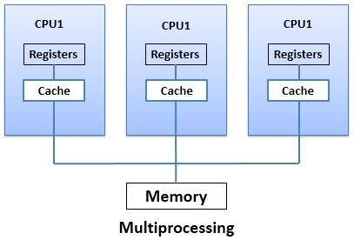

**Multithreading:**

**Multithreading** is the ability of a [central processing unit](https://en.wikipedia.org/wiki/Central_processing_unit) (CPU) (or a single core in a [multi-core processor](https://en.wikipedia.org/wiki/Multi-core_processor)) to execute multiple [processes](https://en.wikipedia.org/wiki/Process_(computing)) or [threads](https://en.wikipedia.org/wiki/Thread_(computer_science)) concurrently, supported by the [operating system](https://en.wikipedia.org/wiki/Operating_system).

